
NORTHERN EDUCATION DIVISION MOCK EXAMINATION
2026 JUNIOR CERTIFICATE EXAMINATION
AGRICULTURE
(100 marks)
Subject Number: J012
Wednesday, 12 February Time Allowed: 2 hours
8:00 – 10:00 am
Question number | Tick if Answered | Do not write in these columns
1-5
6-10
11-15
16-20
21
22
23
24
25
26
27
28
29
30
31
32
33
Instructions
- This paper contains 14 printed pages.
Please check.

- Write your Name, Class and Shift in the
spaces provided on top of each page of this
question paper before you start answering
the questions.

- This paper has three sections. A, B, and C. Answer all the questions.

- In the table provided on this page, tick
questions 21 to 33 if answered.

- Hand in your question paper to the
invigilator when time is called to stop
writing.

Section A (20 marks)
Answer all questions in this section by encircling the letter corresponding to the correct answer. Each question carries 1 mark.

- Which of the following marketing functions is a solution to the problem of bulkiness of agricultural commodities?
- processing
- grading
- storage
- packaging
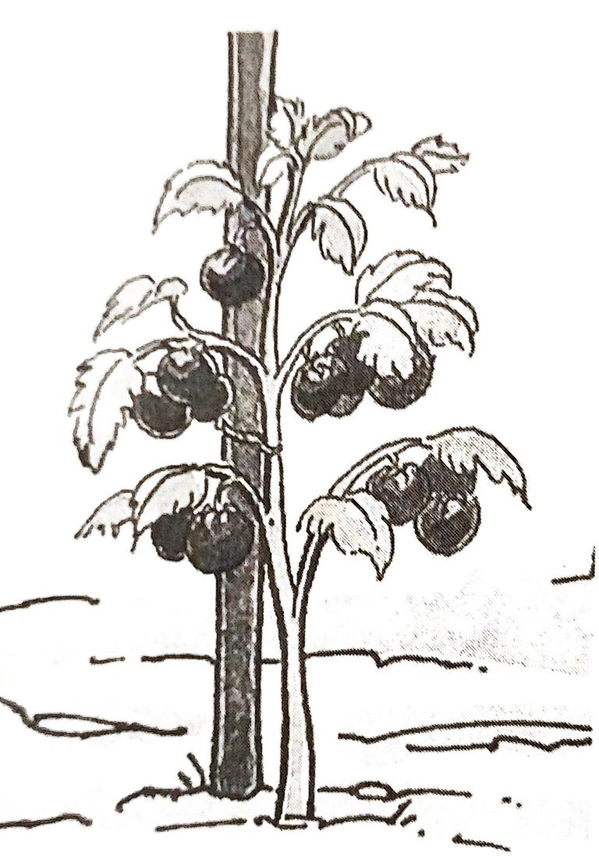
Figure 1 is a diagram of a management practice carried out in tomato production. Use it to answer questions 2 and 3.

Figure 1

- Identify the management practice.
- thinning
- pruning
- staking
- transplanting

- Which of the following is the importance of the management practice in tomato production?
- prevents wilting of plants.
- helps the plant to produce large fruits.
- prevents pests from damaging the plants.
- helps to support the weight of the fruits.

- Which of the following are the symptoms of early leaf spot in groundnuts?
- reddish brown spots surrounded by a yellow band.
- black spots without a yellow band.
- Chlorosis
- curled leaves
- 1 and 3
- 1 and 4
- 2 and 3
- 2 and 4

- Which of the following is a sign of potassium deficiency in maize plants?
- scorched leaf margins.
- whitish interveinal chlorosis.
- leaves become yellow.
- leaves become purple.

- Which of the following is the importance of castration in piglets?
- for easy identification of the piglets.
- to prevent undesirable males from breeding.
- to prevent the spread of the diseases.
- For easy control of the external parasites.

- Which of the following diseases is characterized by bloody diarrhea in chickens?
- Newcastle
- Coccidiosis
- Fowl Typhoid
- Fowl cholera

- A farmer wants to borrow the sum of K160000 at an interest rate of 15% per month.
What would be the total amount of money to be paid after one month?
- K24000
- K175000
- K184000
- K160115

- Which of the following is a limitation of inorganic fertilizers?
- they release nutrients slowly.
- they can introduce pests, diseases and weeds in the field.
- they have low levels of nutrients per unit weight.
- they do not improve soil structure.

- Which of the following is not a main factor of production?
- Land
- Capital
- Climate
- Management

- Which of the following is the first step when writing a report for agricultural research?
- problem identification
- hypothesis formulation
- aim
- title

- Which of the following is the reason for flushing in sows?
- sows to be strong enough for mating.
- to provide enough nutrients for the rapidly growing foetus.
- sows to be strong for farrowing.
- to improve sows fertility.
- 1 and 4
- 1 and 3
- 2 and 4
- 3 and 4

- Which of the following feed would be recommended to pigs which are about to be sold?
- fattener meal
- weaner meal
- growers mash
- creep feed

- The major essential plant nutrient responsible for root development in crops is__
- Nitrogen
- Phosphorus
- Potassium
- Calcium

Figure 2 is a farm implement. Use it to answer questions 15 and 16.
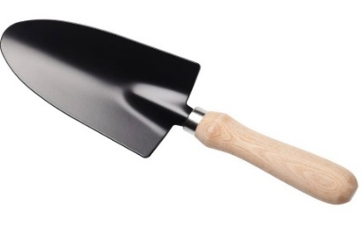
Figure 2
- Identify the farm implement.
- Spade
- hand trowel
- hand folk
- machete

- The farm implement is used for
- mixing manure
- transplanting vegetables
- weeding vegetables
- digging water channels

- Which of the following is a bad food habit which may lead to food insecurity?
- over preparing food
- talking while eating
- over cooking food
- eating without washing hands

- Which of the following is an example of surface irrigation?
- Overhead
- Furrow
- Sprinkler
- Drip

- Which of the following practices on a farm help to conserve forests?
- building check dams
- shifting cultivation
- making fire breaks
- making ridges along the slope

- Which of the following is both a field and crop storage pest?
- Weevil
- leaf miner
- army worm
- stalk borer
Section B (50 marks)
Answer all questions in this section in the spaces provided.
21. a. State any one factor that farmers should consider when selecting crops
for their area.
__________________________________________________________________
(1 mark)
b. Explain any two effects of soil profile on crop production.
__________________________________________________________________________________________________________________________________________________________________________________________________________________________________________________________________________________________________________________________________________
(4 marks)
22. Figure 3 is a diagram of a pest that attacks groundnuts.
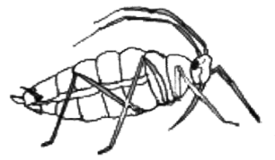
Figure 3
- Identify the pest.
_________________________________________________________________
(1 mark)
- Explain any one way in which the pest in (i) could reduce groundnut production.
______________________________________________________________________________________________________________________________________________________________________________________________________
(2 marks)
- Give any one way of controlling the pest named in (i).
____________________________________________________________________________________________________________________________________
(1 mark)
23. A farmer observed the following signs of a disease on a chicken farm:
- Paralysis of one side
- Difficulty breathing
- Loss of balance
- Green diarrhea
- Twisted of neck or head shaking

- Name the disease that attacked the chickens.
__________________________________________________________________
(1 mark)
- Name the causal organism of the disease.
__________________________________________________________________
(1 mark)
- Give any two ways of controlling the disease.
______________________________________________________________________________________________________________________________________________________________________________________________________
(2 marks)
24. Explain one way in which the following factors of labour affect agricultural
production:
a. Number of people
____________________________________________________________________________________________________________________________________
(2 marks)
b. Health of people
____________________________________________________________________________________________________________________________________
(2 marks)
25. a. State any two ways of caring for transplants.
____________________________________________________________________________________________________________________________________
(2 marks)
b. Name any two reasons for constructing a fence around a vegetative garden.
______________________________________________________________________________________________________________________________________________________________________________________________________
(2 marks)
c. Explain any one advantage of each of the following practices in pig
production:
(i) Teeth clipping
____________________________________________________________________________________________________________________________________
(2 marks)
(ii) Steaming up
____________________________________________________________________________________________________________________________________
(2 marks)
26. The Table below shows demand and supply of beans at different prices. Use
it to answer questions that follow.

Price (MK) | Demand (kg) | Supply (kg)
500 | 680 | 170
1000 | 450 | 270
1500 | 300 | 380
2000 | 200 | 460
2500 | 100 | 560
3000 | 50 | 700

- Plot a graph to show the demand and supply curves of beans on the graph paper provided on page 8.
- Identify the equilibrium price.
__________________________________________________________________
(1 mark)
- What is the quantity of beans supplied at the market when the price is K2500/kg?
__________________________________________________________________
(1 mark)

(5 marks)

27. a. State any two farm business management concepts.
____________________________________________________________________________________________________________________________________
(2 marks)
b. Classify the following vegetables into indigenous and exotic: rape, denje, luni.
Indigenous vegetable | Exotic vegetable
(3 marks)
28. A farmer growing tomatoes kept the following records for the enterprise:
- Bought seed ………………………………….K1200
- Bought insecticides ………………………….K10000
- Bought fertilizer ……………………………..K15000
- Casual labour………………………………...K10000
- Price of tomato per kilogram ………………. K600

- Calculate the total cost of growing tomatoes.

(2 marks)
- Calculate the total income if the farmer produced 500 kg of tomatoes.

(2 marks)
- Calculate profit or loss for the farmer.

(2 marks)
29. A farmer grows crops and raises animals on the same farm.
a. Name the farming system.
__________________________________________________________
(1 mark)
b. Explain any one way in which the farming system would increase food supply.
____________________________________________________________________________________________________________________
(2 marks)
30. A farmer observed the following signs of a disease in pigs:
- Inflammation of the mammary glands
- Failure of the sow to secrete milk
- Secreted milk becomes watery and contains clots of fats.

- Name the disease that attacked the pigs.
__________________________________________________________
(1 mark)
- State the organism that causes the disease.
__________________________________________________________
(1 mark)
- Give any two ways of controlling the disease.
____________________________________________________________________________________________________________________________________
(2 marks)
Section C (30 marks)
Answer all the questions in essay form on the spaces provided.
31. Explain any five ways in which intensive farming can support a growing
population.
__________________________________________________________________________________________________________________________________________________________________________________________________________________________________________________________________________________________________________________________________________________________________________________________________________________________________________________________________________________________________________________________________________________________________________________________________________________________________________________________________________________________________________________________________________________________________________________________________________________________________________________________________________________________________________________________________________________________________________________________________________________________________________________________________________________________________________________________________________________________________________________________________________________________________________________________________________________________________________________________________________________________________________________________________________________________________________
(10 marks)
32. Explain any five factors to consider when selecting an irrigation system.
________________________________________________________________________________________________________________________________________________________________________________________________________________________________________________________________________________________________________________________________________________________________________________________________________________________________________________________________________________________________________________________________________________________________________________________________________________________________________________________________________________________________________________________________________________________________________________________________________________________________________________________________________________________________________________________________________________________________________________________________________________________________________________________________________________________________________________________________________________________________________________________________________________________________________________________________________________________________________________________________________________________________________________________________________________________________________________________________________________________________________________________________________________________________________________________________________________________________________________________________________________________________________________________________________________________________________________________________________________________________________________________________________________________________________________________
(10 marks)
33. Explain any five ways in which essential plant nutrients are depleted from
the soil.
________________________________________________________________________________________________________________________________________________________________________________________________________________________________________________________________________________________________________________________________________________________________________________________________________________________________________________________________________________________________________________________________________________________________________________________________________________________________________________________________________________________________________________________________________________________________________________________________________________________________________________________________________________________________________________________________________________________________________________________________________________________________________________________________________________________________________________________________________________________________________________________________________________________________________________________________________________________________________________________________________________________________________
(10 marks)
END OF QUESTION PAPER
NB : This paper contains 14 printed pages.

